**WEEK 0: EXTRA ACTIVITY 4**

(Modeling number of dot balls in an inning of a PowerPlay)

Here I am following the lines of the instructor’s example and trying to see if I can model the number of dot balls in an inning.( Instructor tried to model the number of 4’s in an inning)

Sample:

IPL powerplay data - The same data instructor used in his example -

<https://drive.google.com/file/d/1bc9qOk1lxSGzMBjk5PuPt9gmx176lAbJ/view>

Or my copy - <https://github.com/pradeepmondal/PowerPlayScript/blob/master/PowerPlay.csv>

Model : Number of dot balls in an inning of a powerplay..

Total number of innings = 1598

Here I tried to read the CSV file and extract the information using my own created python script that can be found in my github public repository -

<https://github.com/pradeepmondal/PowerPlayScript>

The result information file -

<https://github.com/pradeepmondal/PowerPlayScript/blob/master/result.csv>

With the help of the CSV file generated the calculations are in the next page -

Define X: Number of dot balls in an inning occuring in the first 36 legal deliveries (powerplay) of an inning.

P(X=0) = 0/1598 = 0

P(X=1) = 0/1598 = 0

P(X=2) = 0/1598 = 0

P(X=3) = 0/1598 = 0

P(X=4) = 0/1598 = 0

P(X=5) = 0/1598 = 0

P(X=6) = 0/1598 = 0

P(X=7) = 1/1598 = 0.0006

P(X=8) = 0 /1598 = 0

P(X=9) = 2 /1598 = 0.0012

P(X=10) = 2/1598 = 0.0012

P(X=11) = 16/1598 = 0.0100

P(X= 12) = 33/1598 = 0.0206

P(X=13) = 32/1598 = 0.0200

P(X=14) = 63/1598 = 0.0394

P(X=15) = 89/1598 = 0.0557

P(X=16) = 122/1598 = 0.0763

P(X=17) = 160/1598 = 0.1001

P(X=18) = 184/1598 = 0.1151

P(X=19) = 182/1598 = 0.1138

P(X=20) = 179/1598 = 0.1120

P(X=21) = 168/1598 = 0.1051

P(X=22) = 126/1598 = 0.0788

P(X=23) = 98/1598 = 0.0613

P(X=24) = 59/1598 = 0.0369

P(X=25) = 46/1598 = 0.0288

P(X=26) = 11/1598 = 0.0068

P(X=27) = 14/1598 = 0.0088

P(X=28) = 7/1598 = 0.0044

P(X=29) = 4/1598 = 0.0025

P(X=30) = 0/1598 = 0

P(X=31) = 0/1598 = 0

P(X=32) = 0/1598 = 0

P(X=33) = 0/1598 = 0

P(X=34) = 0/1598 = 0

P(X=35) = 0/1598 = 0

P(X=36) = 0/1598 = 0

Now let us check whether this follows the Binomial distribution.

Let p be the probability of success.

p = P(occurrence of a dot ball)

= number of dot balls occurred in all the legal deliveries during powerplay of all innings / total number of balls

= 30368 / (1598*36) = 30368 / 57528 = 0.528

Using the Binomial distribution: n = 36, x : {0, 1, …., 36}, p = 0.528 , I, calculated the binomial distribution using my own script binom.py in my github repository and rendered in Binom.csv

binom.py - <https://github.com/pradeepmondal/PowerPlayScript/blob/master/binom.py>

Binom.csv - <https://github.com/pradeepmondal/PowerPlayScript/blob/master/Binom.csv>

Finally I tabulated all the data in a Google Sheet file and plotted Chart -

<https://docs.google.com/spreadsheets/d/1i-1GH2phKiKUhn7EbGil5BIfwJIEFMD1HrZsCZY_1Rc/edit?usp=sharing>

And finally the result -

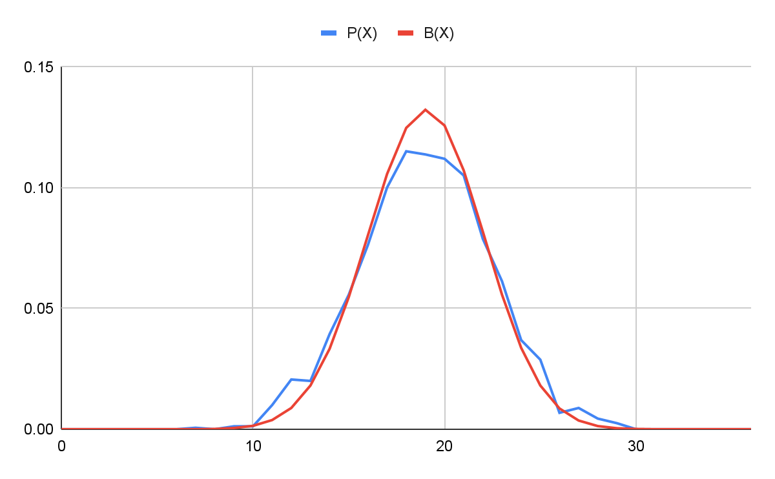

We can see that P(X) vs X is a good approximation of B(X) vs X

Hence we can model the number of dot balls in an inning as a binomial distribution (with n = 36, p=0.528).